

Project Interim Report

On

Digital Stopwatch Logic Simulation (Using Core Java & OOP Concepts)
RU-100-01-00012
Object Oriented Programming with Java

SESSION: 2025-26

Submitted By
Riya Rani
RU-25-11190

Bachelor of Technology in Computer Science & Engineering with Data Science in association with Google

Under the Guidance of Mr. Ashish Shivhare

SCHOOL OF COMPUTER SCIENCE AND ENGINEERING RUNGTA INTERNATIONAL SKILLS UNIVERSITY
BHILAI, CG

(April 2026)
CERTIFICATE

ACKNOWLEDGEMENT

ABSTRACT

This project presents a digital stopwatch developed using the principles of Object-Oriented Programming in Java. The main idea of this project is to create a simple time-measuring system that behaves like a real stopwatch used in daily life. The stopwatch can start, stop, reset, and display the elapsed time accurately.

Instead of using complex hardware, this project uses system time functions to calculate time efficiently. The design focuses on clarity, simplicity, and proper use of programming concepts like encapsulation and class-based structure. This project helps in understanding how real-world devices can be simulated using programming and improves logical thinking as well as coding skills.

INTRODUCTION

Time measurement plays an important role in many real-life activities such as sports, scientific experiments, and daily tasks. A stopwatch is a useful device that helps measure time intervals accurately. In this project, a digital stopwatch is developed using Java by applying Object-Oriented Programming (OOP) concepts.
The main idea behind this project is to understand how a real-world system can be converted into a computer program. The stopwatch works by recording the starting time and calculating the difference when it is stopped. It also provides options to reset and reuse the stopwatch.

Key Features of the Project:
- Start the stopwatch to begin time tracking
- Stop the stopwatch to pause time
- Reset the stopwatch to clear previous time
- Display the elapsed time in milliseconds
- Simple and user-friendly design

OBJECTIVES
- To design a stopwatch using Java OOP concepts
- To implement time tracking functionality
- To understand encapsulation and state management
- To simulate a real-world application
- To improve logical and programming skills

SCOPE

This project is suitable for beginners learning Java and OOP concepts. It can be extended in the future by:
- Adding GUI (Graphical User Interface)
- Integrating with mobile or web applications
- Adding lap time feature

SYSTEM REQUIREMENTS

Hardware:
- Computer/Laptop with minimum 4GB RAM
Software:
- Java JDK
- IDE (VS Code / Eclipse / IntelliJ)

METHODOLOGY

The project works in the following steps:
- Create a Stopwatch class
- Initialize variables (startTime, elapsedTime, isRunning)
- Start the stopwatch using system time
- Stop the stopwatch and calculate elapsed time
- Reset all values when required
- Display elapsed time

FLOWCHART

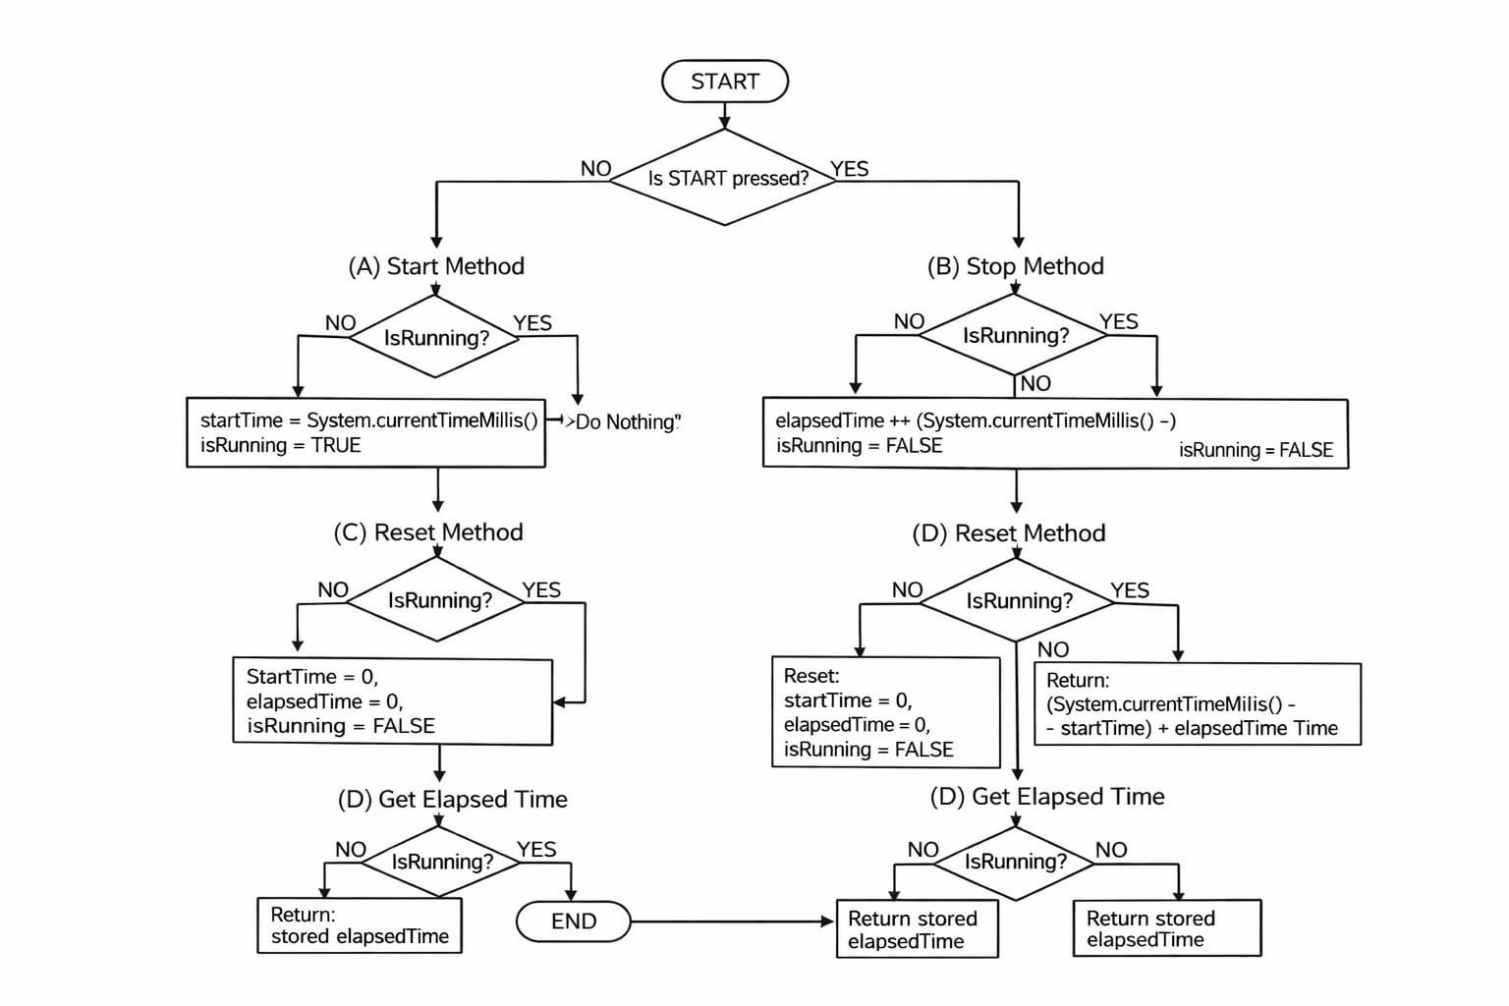

IMPLEMENTATION

Stopwatch Class
- Manages all timing operations
- Stores start time and elapsed time
- Controls stopwatch state
Main Class
- Creates object of Stopwatch
- Calls methods (start, stop, reset)
- Displays output

INPUT/OUTPUT

FUTURE ENHANCEMENTS

- Add GUI using Java Swing
- Add lap timing feature
- Store time records in file/database
- Mobile app integration

CONCLUSION

This project successfully demonstrates the use of Object-Oriented Programming concepts in Java. The digital stopwatch works accurately and helps in understanding time-based logic, state management, and real-world simulation. It improves coding and problem-solving skills.

REFERENCES

- Java Documentation (Oracle)
- OOP Concepts Textbooks
- Online tutorials (GeeksforGeeks, TutorialsPoint)

